Internal Transfers Review Overview  - Internal Transfer Review completed June 2022 with board approval September 2022  - 10 Recommendations made, 9 accepted, 1 partially accepted, and 1 not accepted  - 100% Recommendations completed | 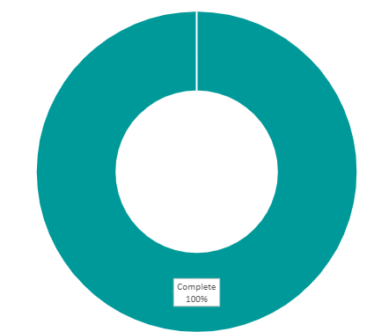
Recommendation | Update
I3. Combine the internal transfer waiting list and the main waiting list as one. It is felt this is fairer and would remove the issue around no clear policy on which list to use when there is an allocation. The current points system would put internal transfer applicants at a disadvantage due to generally being more suitably housed than main waiting list applicants, therefore this needs to be considered when PFH combine the lists, potentially looking at average points to boost internal transfer applicants to match non-residents. | Update – January 2025 – Complete  Internal and external applications are now combined within the same waiting list and live applications are now in Civica.  There is work to do on 'pending' applications - i.e. applicants who have not returned proofs, or who did not respond to the invitation to complete the new Civica assessment form.  Over the coming weeks and months, we will contact all such applicants again and invite them to complete a new application via the Civica customer portal.
I5. A full review of existing internal transfer applications to be undertaken using the principles of recommendation 4 including checking circumstances, points, area choices and associated paperwork ensuring clear record keeping | Update – January 2025 – Complete  All existing transfer applicants have received review forms so that they can be assessed under the proposed post-Civica go live system. All new internal transfer applicants are being assessed both under the existing assessment system, and the one which will be used when Civica goes live. This is so that the correct information will be held in Civica and internal applicants will show on the list just as external applicants will do. All other related processes remain the same - home visits, assurance form, information on areas chosen and demand levels etc. All those who returned their Civica form have been reassessed under the Civica assessment process, and have live applications on Civica.

