Grounds Maintenance Review Overview  - Grounds Maintenance Review completed August 2024 with board approval September 2024  - 12 Recommendations made, 7 accepted, 5 partially accepted  - 50% Recommendations completed, 42% recommendations in progress, 8% pending | 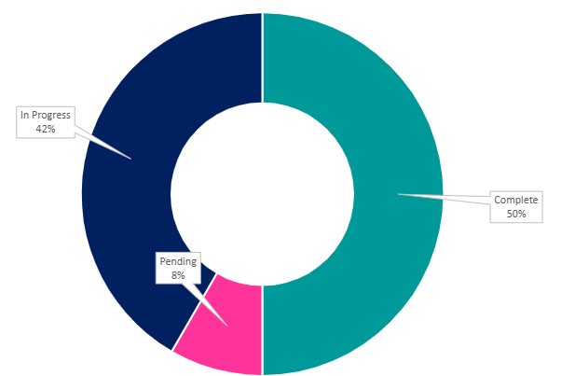
Recommendation | Update
GM2 - PFH site staff to take more ownership on Grounds Maintenance standards on schemes – creating a network of everyone keeping the service to account received | Update – July 2025 – In Progress  The Property Service Manager and Surveyors have been reviewing all resident feedback received since the new Grounds Maintenance Contract commenced. Feedback and performance are discussed at monthly contractor meetings, and the Surveyors are meeting every 3 weeks in rotating schemes to review service delivery on site. The proposal for an Estates Officer to support this is being considered at the Governance and Remuneration Committee in July.
GM3 - Explore having resident inspectors who support with the communication of any issues raised in their areas | Update – July 2025 – In Progress  Following the proposal for an Estates Officer review at the Governance and Remuneration Committee in July, work will commence on the creation of a resident inspector group, residents will be invited to design a process and brief for resident inspectors including a mystery shopper questionnaire, and will work with our Estates Officer if the proposal is accepted, or alongside the Property Services Manager and Surveyors. Initial interest has been sought from residents interested in becoming a ‘Resident Inspector’ with 28 residents putting their names forward.
GM4 - Job reports from contractors should show before and after photos of the same area, not just an overview of the works done | Update – July 2025 – Pending  A contractor portal is in use, PFH staff have access to job reports, future schedules. Next step is to enable the before and after photograph function.
GM5 - Introduce a Tree Management Policy which is clearly defined with a budget that allows works to be completed more efficiently. | Update – July 2025 – Pending  A Tree Management Policy has been created by the Property and Compliance Manager, this will be reviewed by all service managers, and consulted with through resident groups to ensure we are comfortable that it captures everything needed before cascading to the teams.
GM6 - PFH to develop a consistent approach for non-PFH owned green spaces / trees / hedges that impact PFH homes that details how it solves these problems with clear communication to the relevant land owner and resident who this effects. | Update – July 2025 – Pending  A guidance document has been designed by the Property and Compliance Manager, this will be reviewed by all service managers to ensure we are comfortable that it captures everything needed. Once complete it will be presented to the Scrutiny group for review and feedback.
GM7 - Introduce the putting a card through the doors of residents who have had a private grounds maintenance visit, so the resident knows exactly what has been done and how long they were there to ensure service is value for money | Partially Accepted - Update – July 2025 – In Progress  The new recommended gardener service under our More Than A Landlord project, launched in April 25 and provides residents with greater choice and control as endorsed by the Resident Committee. Existing residents of the previous private gardener service offered by PFH were provided with the choice to continue with the service they were on, or go with the recommended gardener service instead. Communication on updates and works provided has been agreed between the residents and the gardeners. PFH will survey these residents to evaluate satisfaction levels with the service and communication they receive before marking the action as complete.
GM8 - PFH to implement a banded private grounds maintenance service reflective of the size of the resident’s garden and scope of works | Partially accepted - Update – July 2025 – Complete  The Resident Committee endorsed an approach to blend the service charged private garden service with the new recommended gardener service under our More Than A Landlord project, this was launched in April 25 and provides residents with greater choice and control.
GM9 - Introduce tracking of ad-hoc grounds maintenance requests to ensure these are followed up | Update – July 2025 – In Progress  To be built into Housing management system (Civica) processes during in phase 2 implementation. As result of other priorities including regulatory inspection and changes in personnel progress with phase 2 has been delayed.

